Risky Driver Insights & Operational Recommendations for ANT
Worksheet 1: Risky Drivers
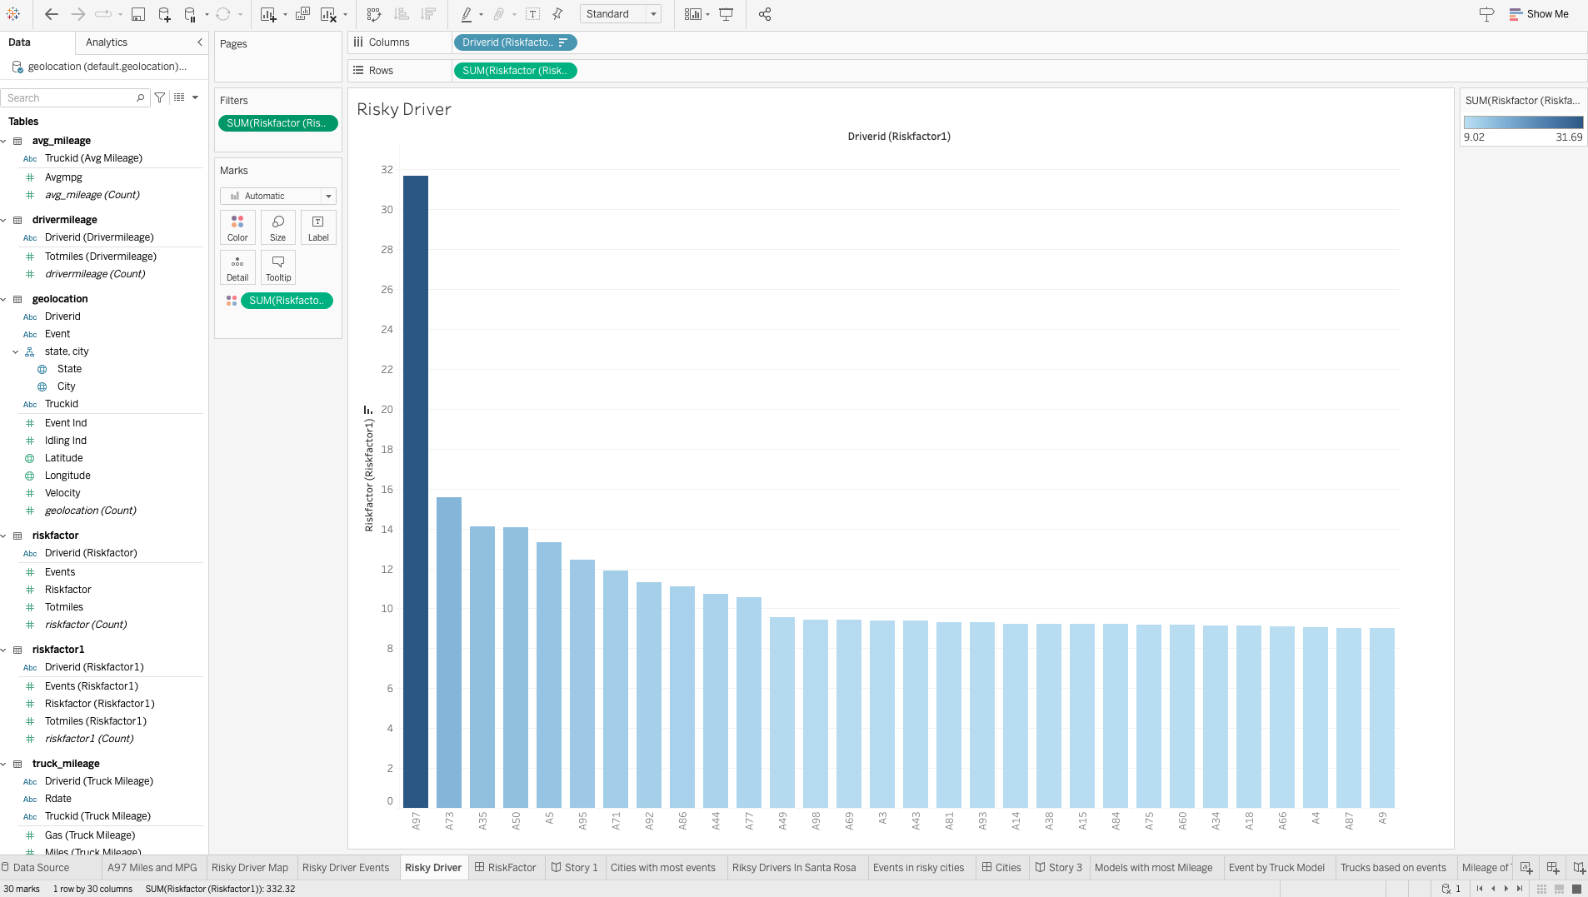

Risky Driver Bar Chart
- What it shows: The bar chart ranks drivers by their risk factor, calculated based on various unsafe driving behaviors.
- Observation: Driver A97 clearly stands out with a significantly higher risk factor (over 30), while others hover below 20.
- Interpretation: A97's driving behavior is disproportionately risky compared to peers and requires immediate attention.

Worksheet 2: Driver A97 Miles and MPG
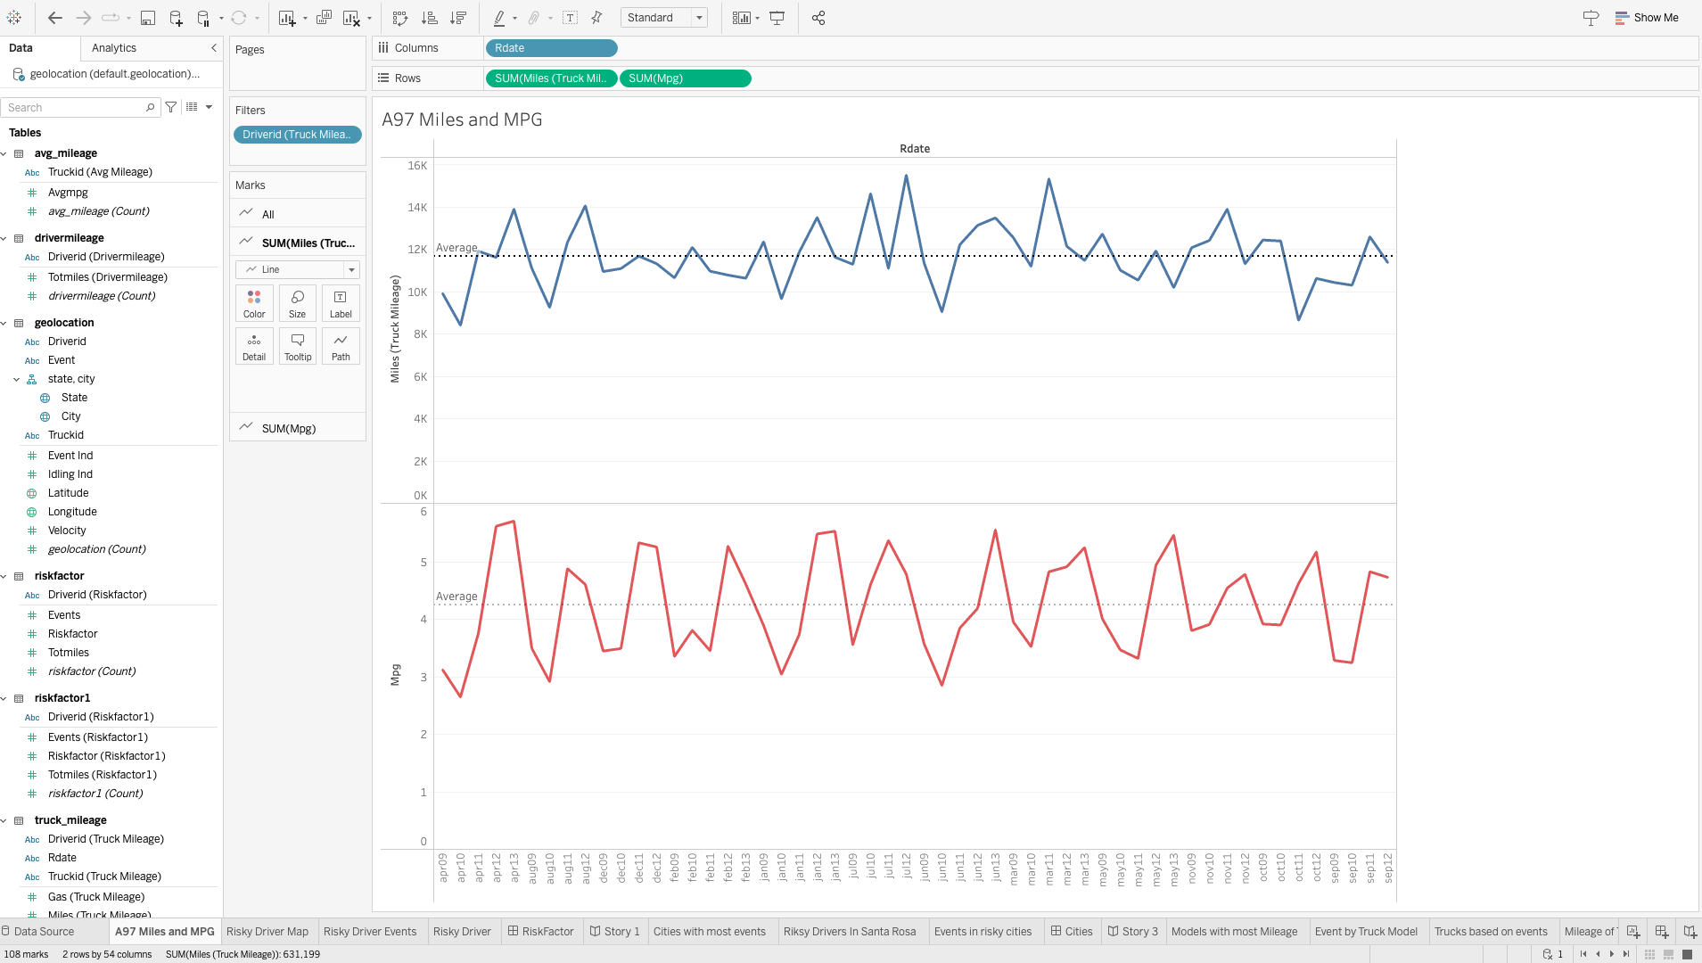

A97 Mileage and MPG Over Time
- What it shows: A line graph showing monthly trends for mileage and fuel efficiency (MPG) for A97.
- Observation:
  - Mileage fluctuates around 10–12K miles with some spikes.
  - MPG has a general upward trend, indicating slight improvements in efficiency.
- Interpretation: A97 may be improving fuel usage over time but is still covering large distances, increasing exposure to risk.

Worksheet 3: Risky Drivers Map
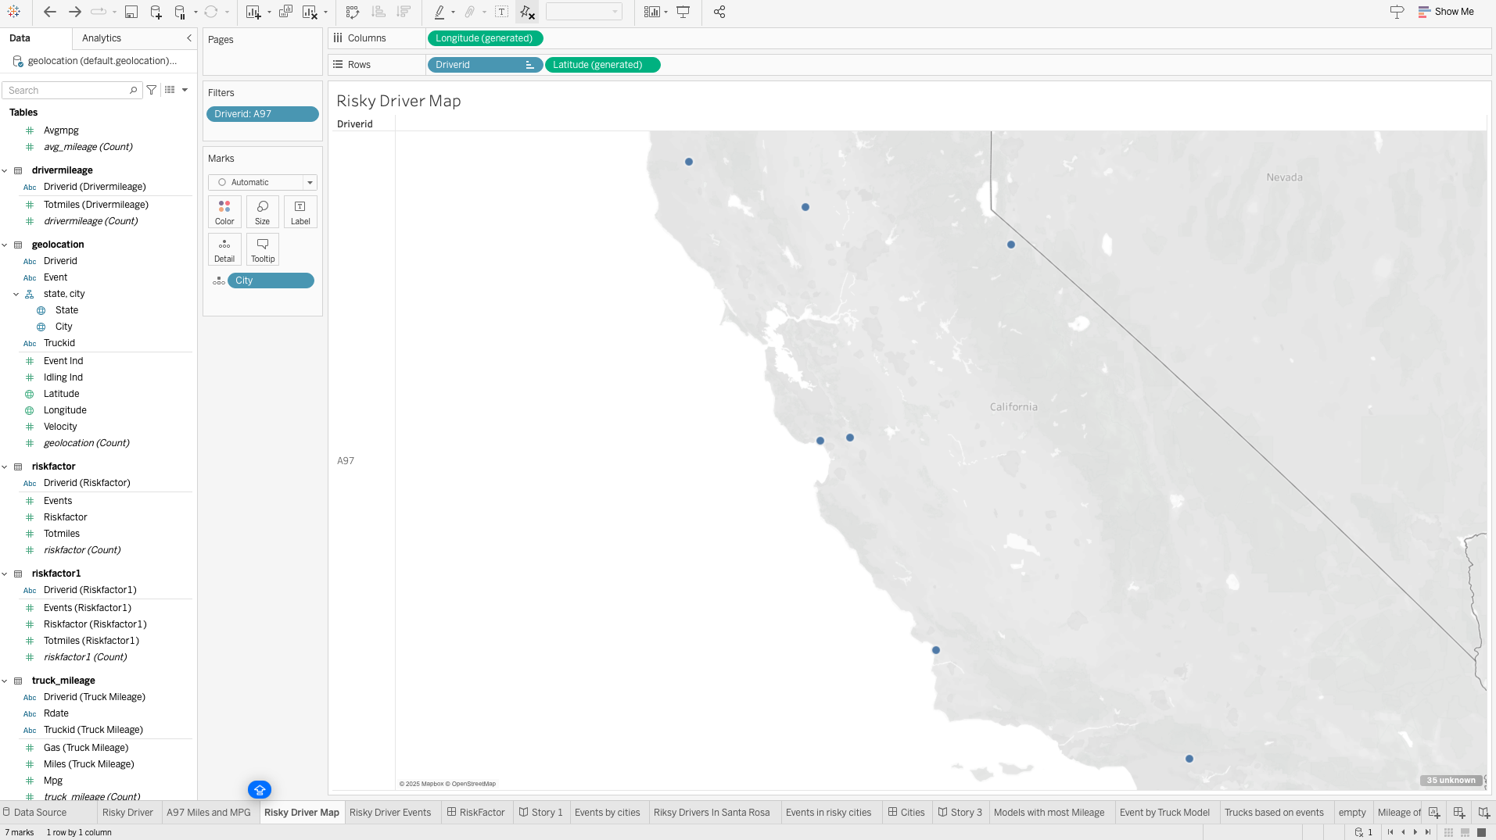
Worksheet 4: Risky Driver Events
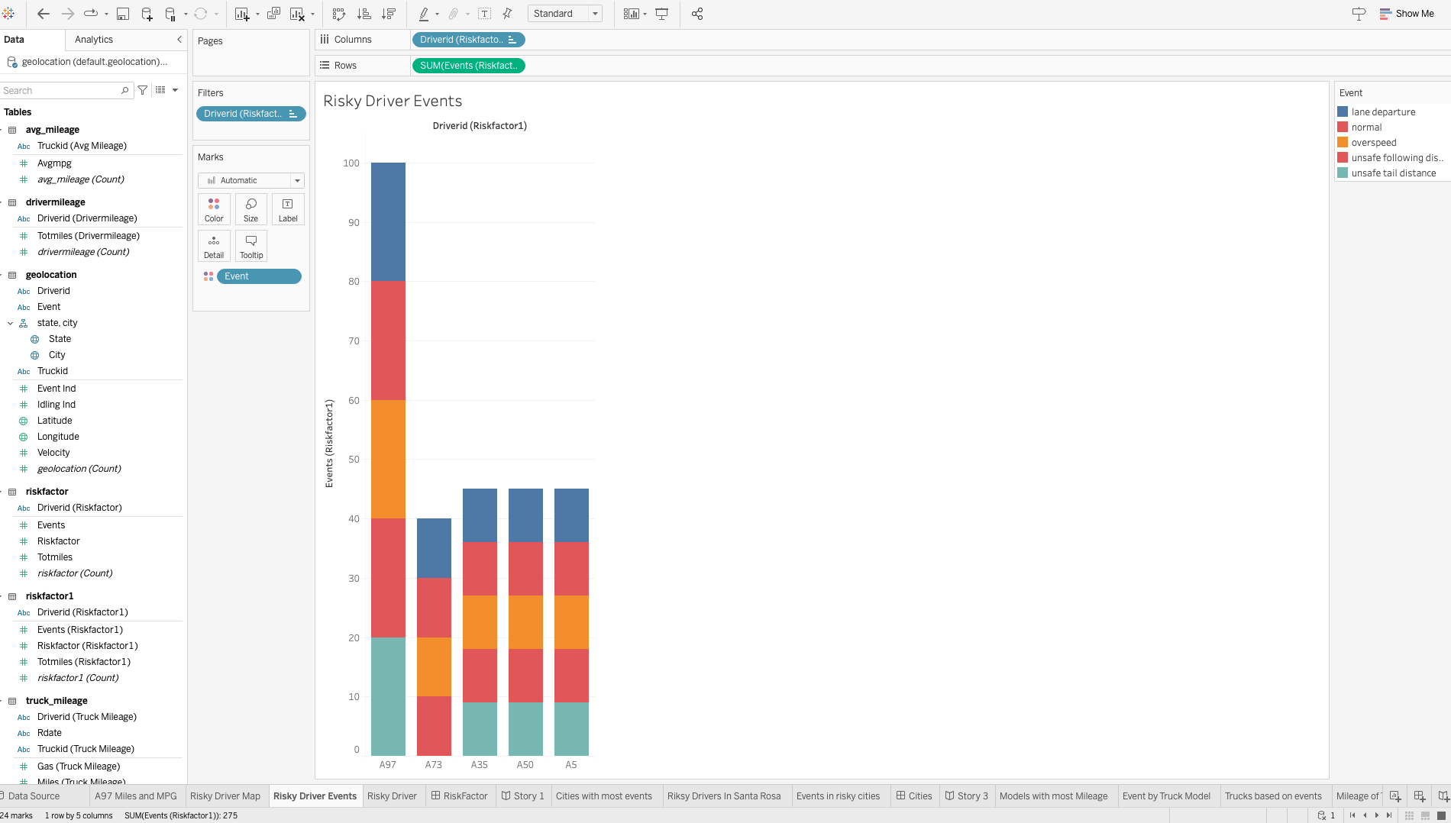

Risky Driver Events (Stacked Bar Chart)
- What it shows: Breakdown of the types of unsafe events (e.g., lane departure, overspeed) for the top 5 risky drivers.
- Observation: A97 has high instances across all categories, particularly lane departure and unsafe following distance.
- Interpretation: A97 demonstrates not just frequency but diversity in risky behaviors, implying a lack of caution and awareness.
Dashboard:
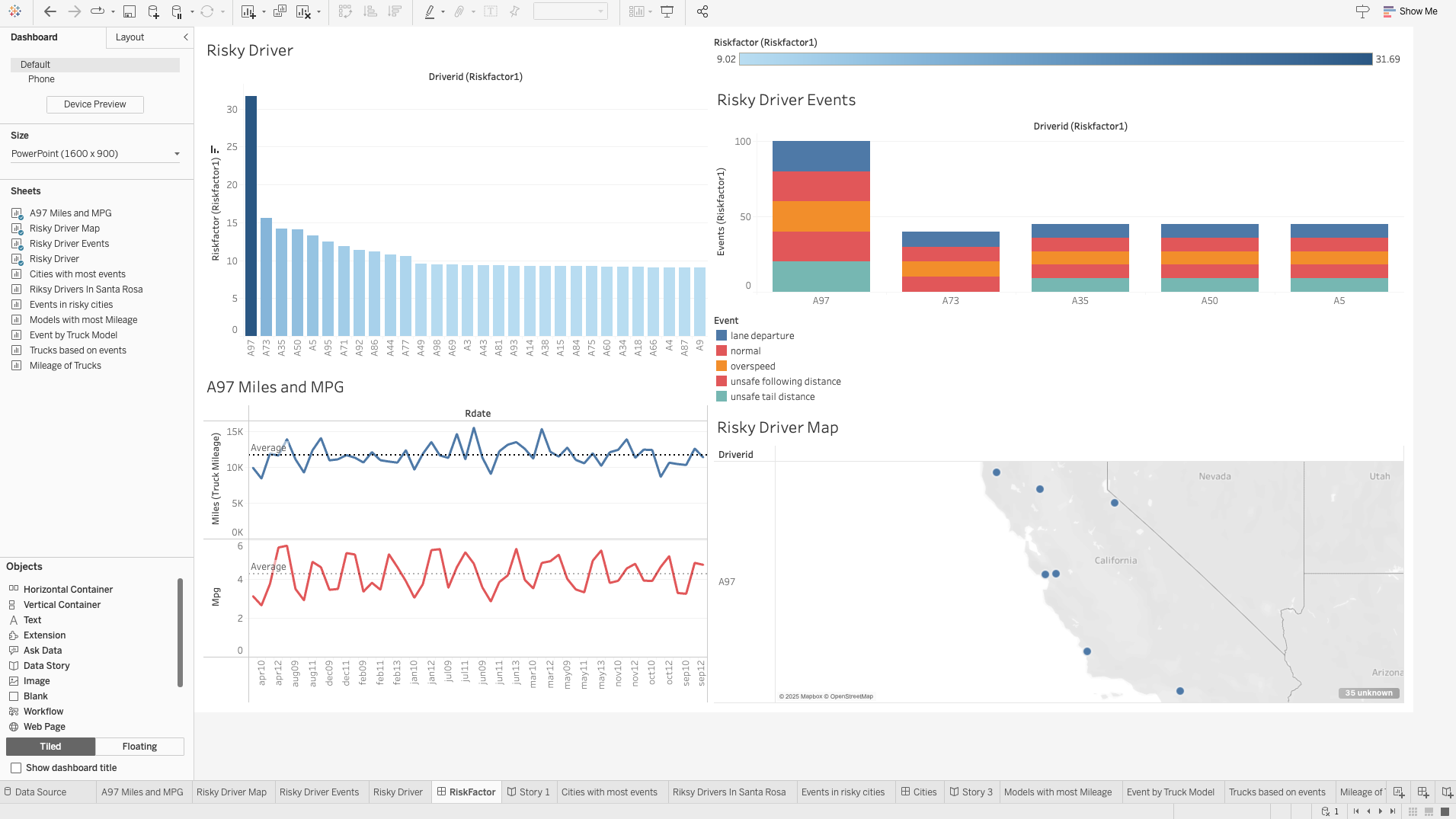

📈 Summary Story:
Driver A97 emerges as the most critical safety concern in the fleet with a risk factor of 31.69 and over 100 risky events. This driver also logs high mileage but shows marginal improvements in fuel efficiency. The risky behavior spans multiple categories and is concentrated in specific regions, especially within California. While MPG has improved slightly, unsafe practices dominate the safety profile.

Recommendations for ANT:

✅ 1. Initiate Targeted Driver Training
- Focus on A97 and other top risky drivers.
- Address specific behaviors like lane departure and unsafe following distance through simulation or coaching.

✅ 3. Introduce Incentives for Safe Driving
- Gamify safety: reward drivers for improved MPG and reduced incidents over time.
- This could sustain MPG improvements seen in A97 and encourage safer driving across the board.
Worksheet 1: Events by cities
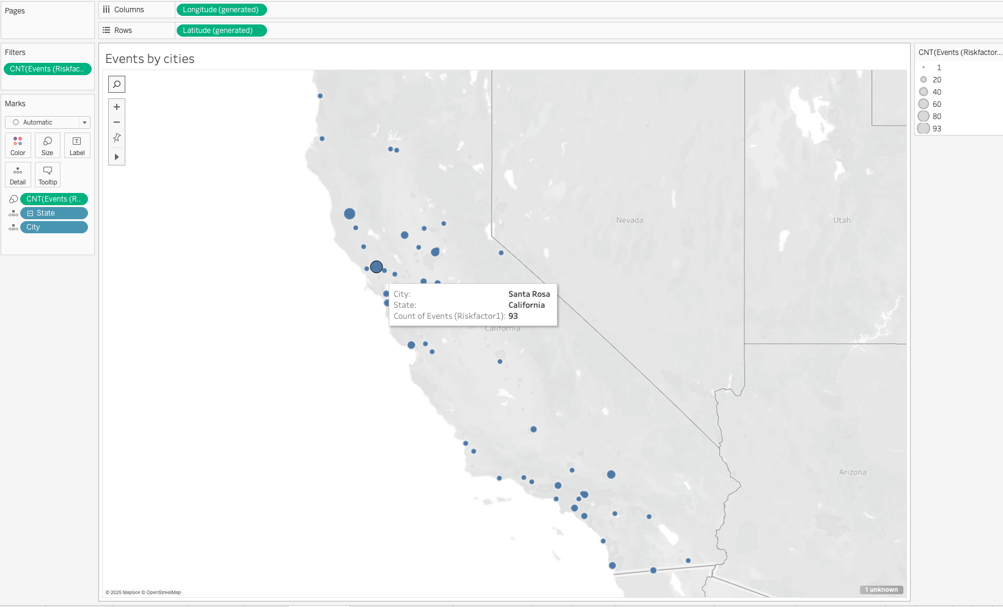

Map: Events by Cities
- Observation: The city of Santa Rosa has the highest concentration of safety events with 93 events.
- Interpretation: This may indicate poor road conditions, high traffic congestion, or habitual driving issues in that city.

Workesheet 2: Risky drivers In Santa Rosa
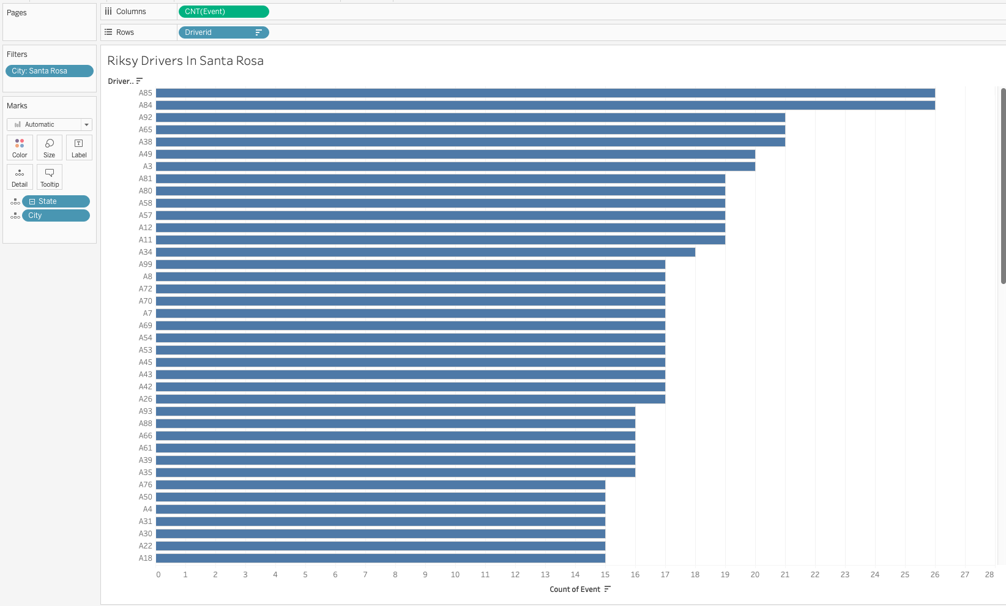

Bar Chart: Risky Drivers in Santa Rosa
- Observation: Driver A85 is responsible for the most events in Santa Rosa, followed closely by A84 and A92.
- Interpretation: These drivers contribute significantly to the city's risk profile and might require targeted intervention, though A85 is not among the top global risky drivers, indicating a localized issue rather than a high-risk profile.
Worksheet 3:
Events in risky cities
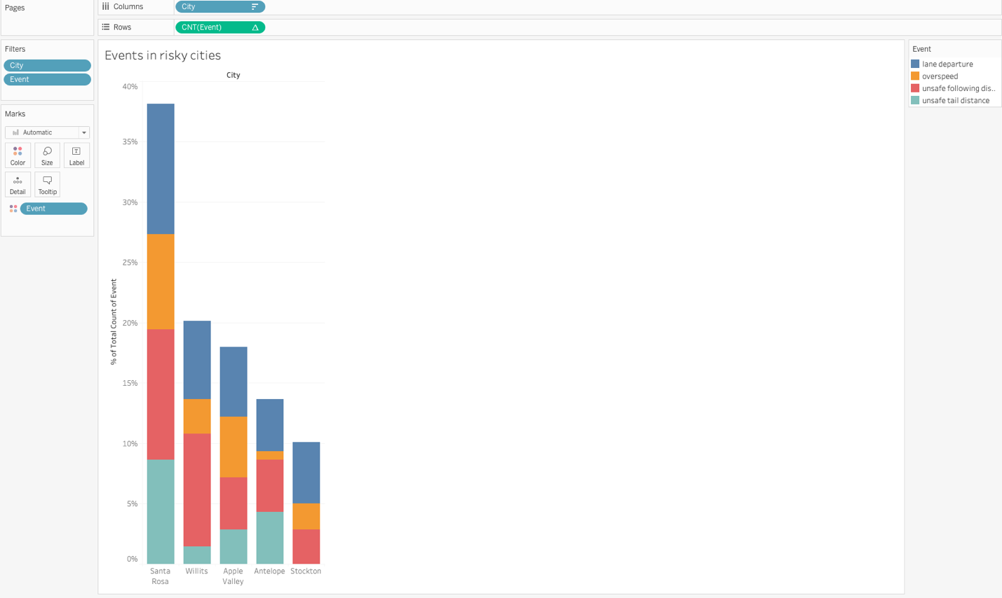

Stacked Bar Chart: Event Type Distribution in Top Risk Cities
- Observation:
  - Lane departure and unsafe following distance are the most frequent event types.
  - Santa Rosa again dominates, accounting for nearly 40% of all safety-related events among the top 5 cities.
- Interpretation: These are serious events that could lead to major accidents, showing the need for better lane discipline and distancing behavior, especially in Santa Rosa.
Dashboard
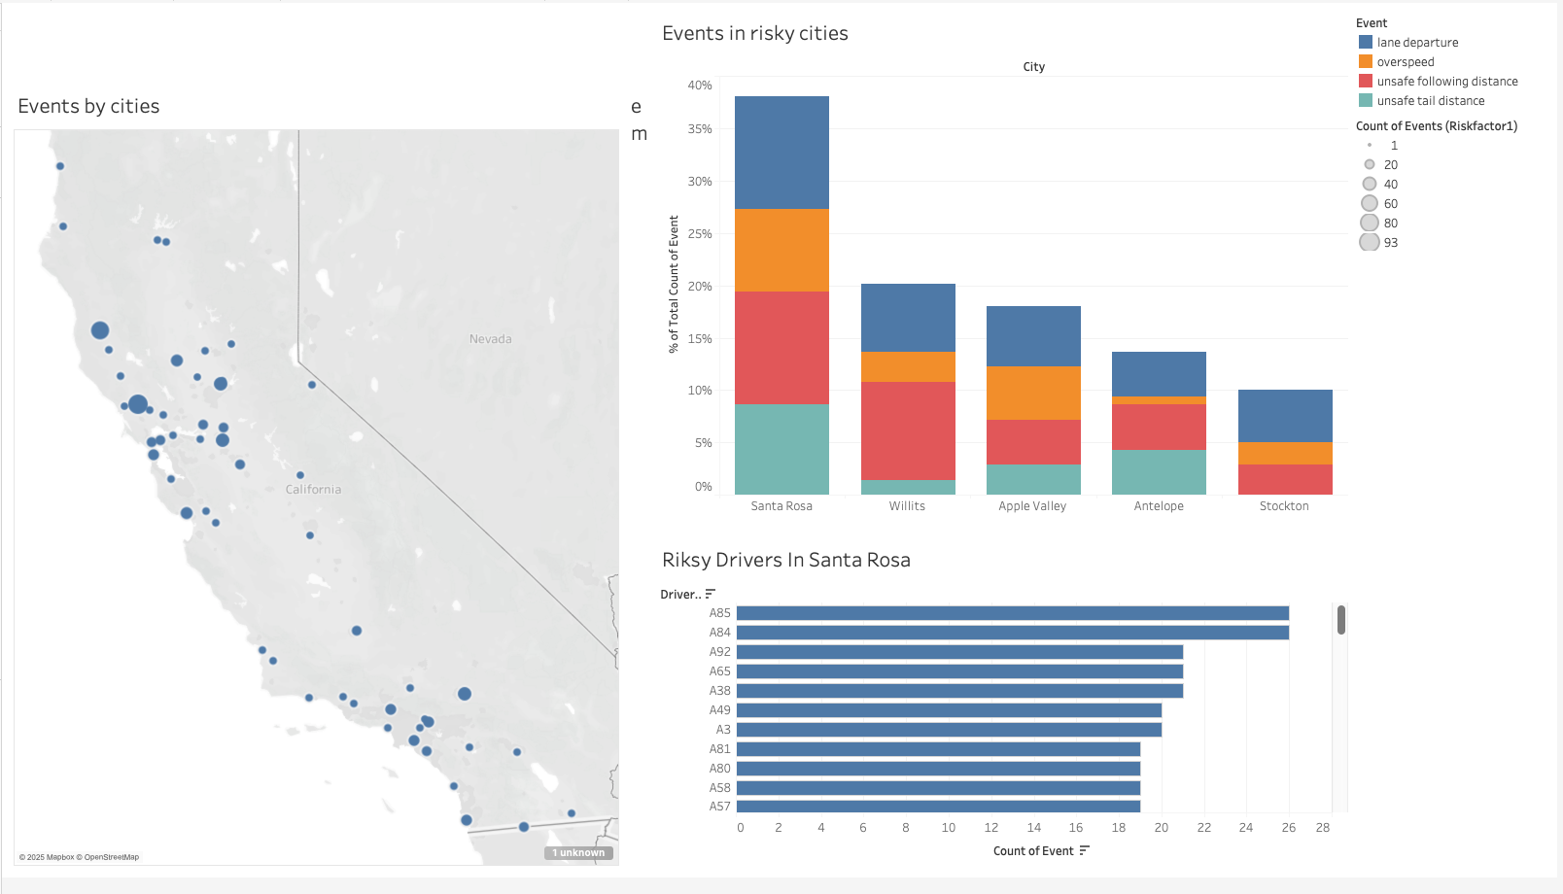

Overall Narrative:
Santa Rosa emerges as the riskiest city with both the highest total number of safety events and multiple drivers repeatedly involved. Although the drivers here aren't globally the most dangerous, their behavior within the city raises concerns. The dominant event types are lane departures and unsafe following distance, which suggests localized behavioral or environmental challenges.

Recommendations for ANT:

1. Localized Driver Training & Road Hazard Analysis
- Deploy in-person or virtual driver training focused on lane keeping and safe following techniques in Santa Rosa.
- Conduct road safety audits in areas with high event density to determine whether road design contributes to violations.

2. Geo-Fencing & Alerts
- Use telematics to set up geo-fencing in risky areas like Santa Rosa.
- When a driver enters this zone, trigger alerts or reminders to exercise extra caution.

Worksheet 1: Models with most mileage
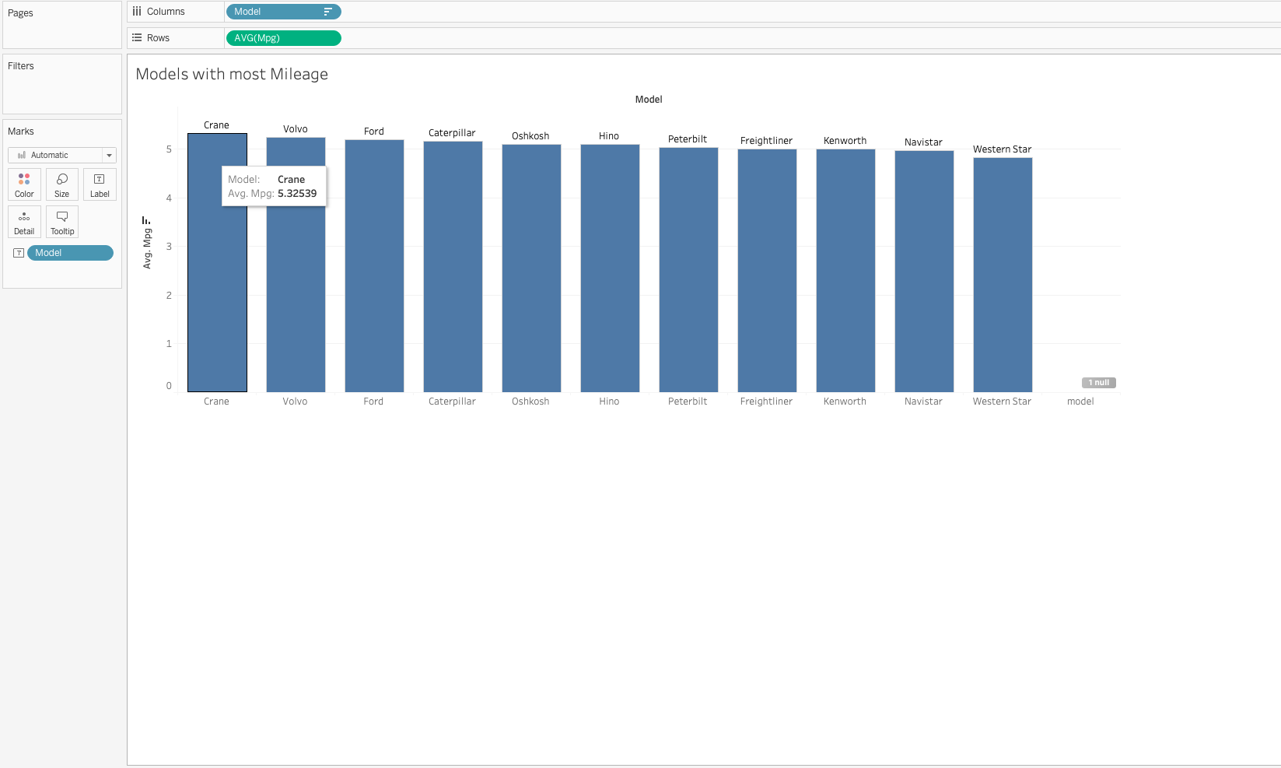

Models with Most Mileage
Chart Type: Vertical Bar Chart (Models vs Avg MPG)

📌 Interpretation:
- Crane has the highest average MPG (~5.32), making it the most fuel-efficient model.
- Most truck models range between 5.0 to 5.3 MPG, with Western Star on the lower end.
- Despite high efficiency, some models like Caterpillar and Ford also show higher event counts, indicating a trade-off between efficiency and safety.

🔍 Insight:
Fuel Efficiency doesn’t guarantee safety. Models like Crane provide better mileage and fewer incidents, making them suitable for long-distance routes.

Worksheet 2: Events by truck model

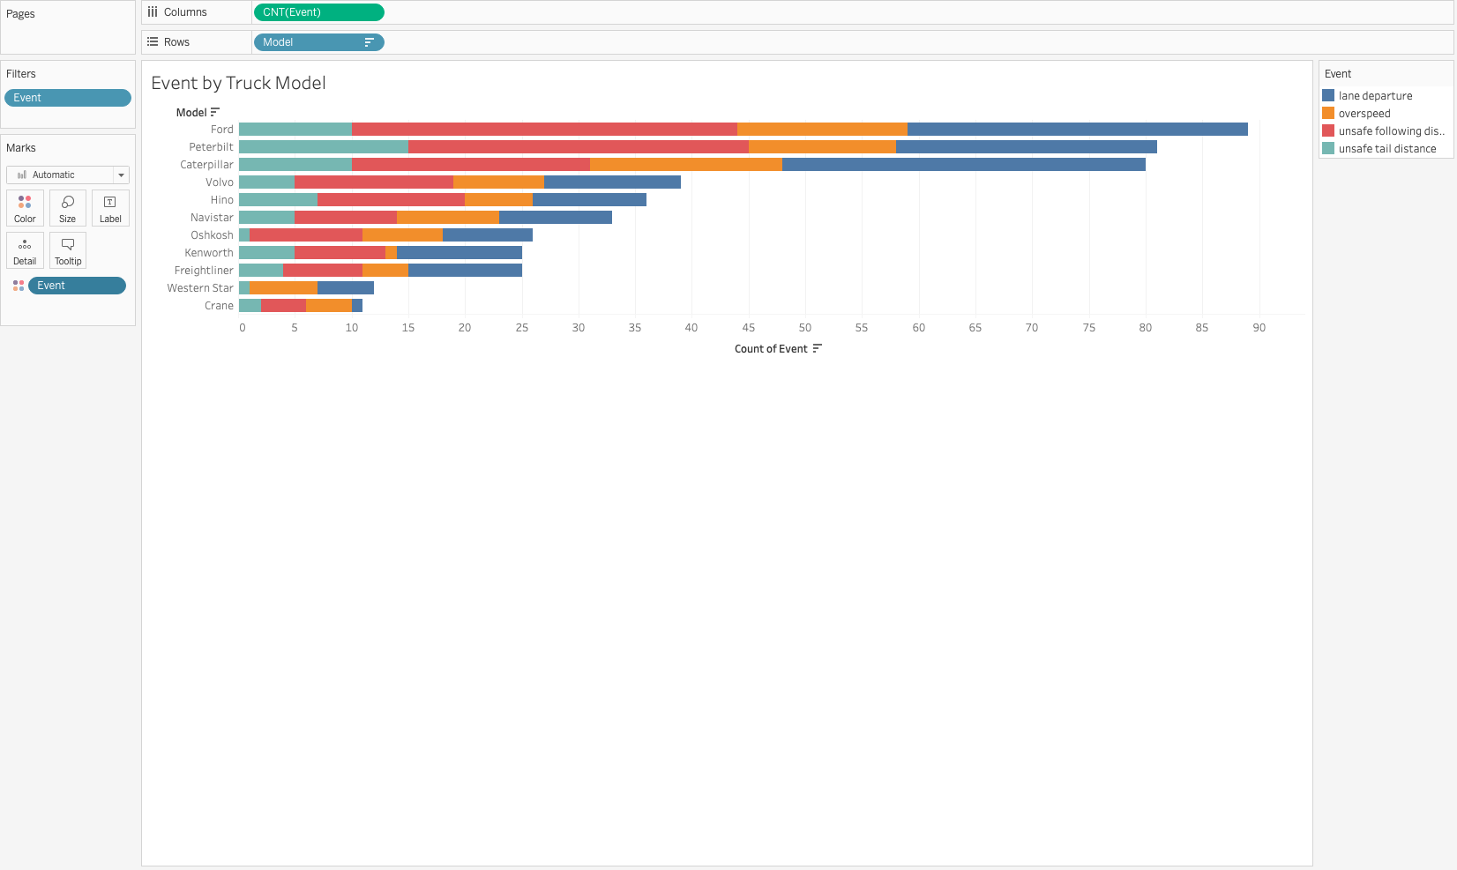

Event by Truck Model
Chart Type: Horizontal Stacked Bar Chart (Models vs Event Count)

📌 Interpretation:
- Ford has the highest number of events among all truck models, followed closely by Peterbilt and Caterpillar.
- These events are mostly lane departure and unsafe following distance, indicating possible design, driver behavior, or use-case mismatches.
- Models like Crane and Western Star show fewer incidents, suggesting safer or less frequent use.

🔍 Insight:
Truck model choice significantly affects event frequency. Ford trucks may require driver-specific training or phased decommissioning from high-risk routes.

Worksheet 3: Trucks with most events
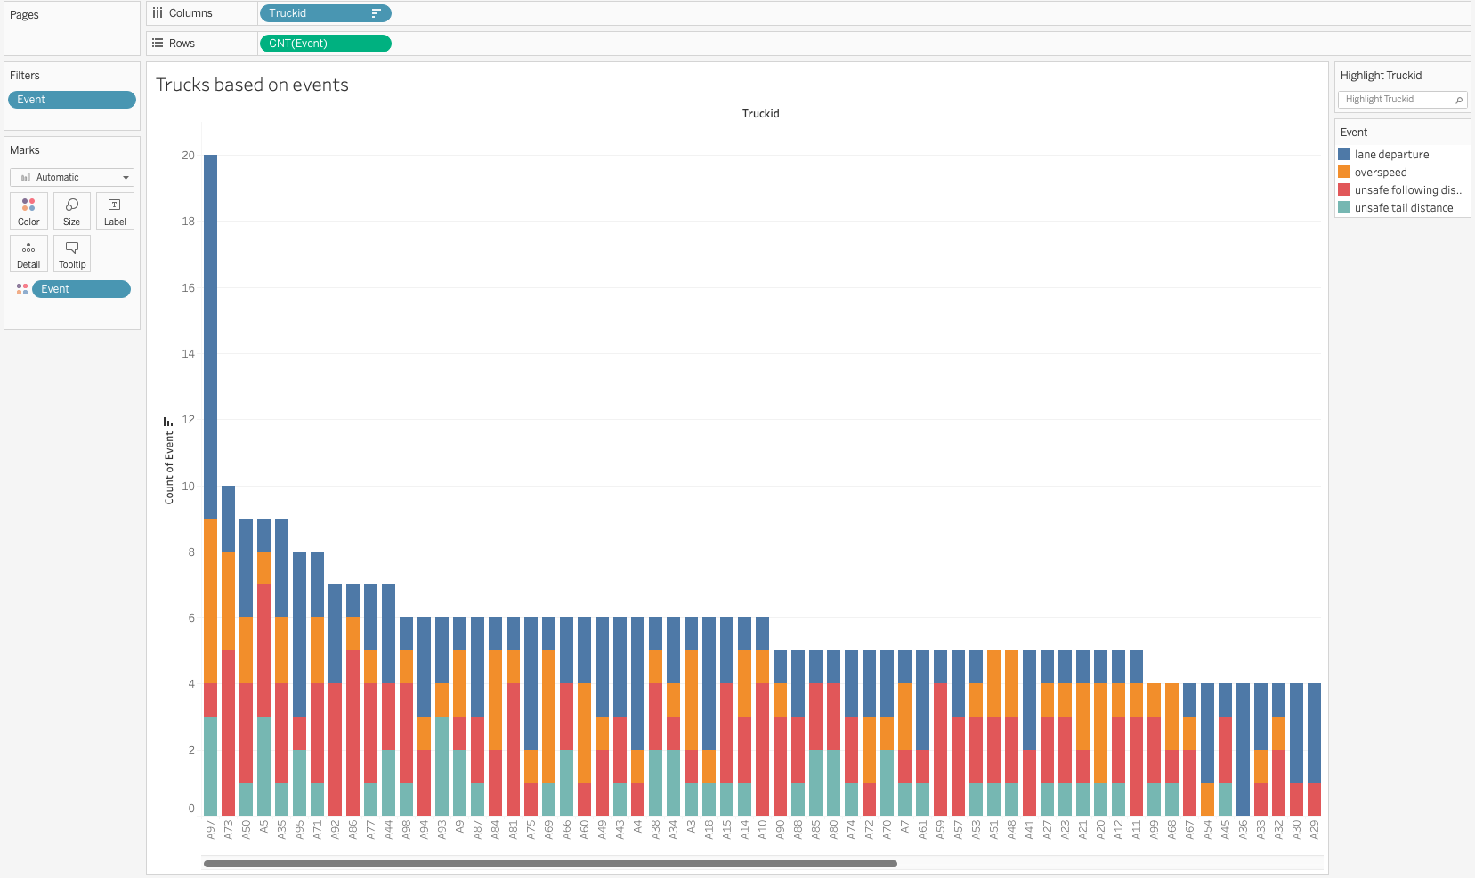
Stacked Bar Chart (Truck IDs vs Count of Events)

📌 Interpretation:
- Truck A73 has the highest number of recorded events (20), followed by A52 and A25.
- Common event types across the high-risk trucks include lane departure, unsafe following distance, and overspeed.
- Several trucks with fewer total events still show risky patterns (e.g., having many safety-related incidents).

🔍 Insight:
A73 should be prioritized for driver review, maintenance checks, or usage restrictions. Trucks like A52 also show elevated events despite being high-mileage vehicles.
Worksheet 4: Mileage of trucks
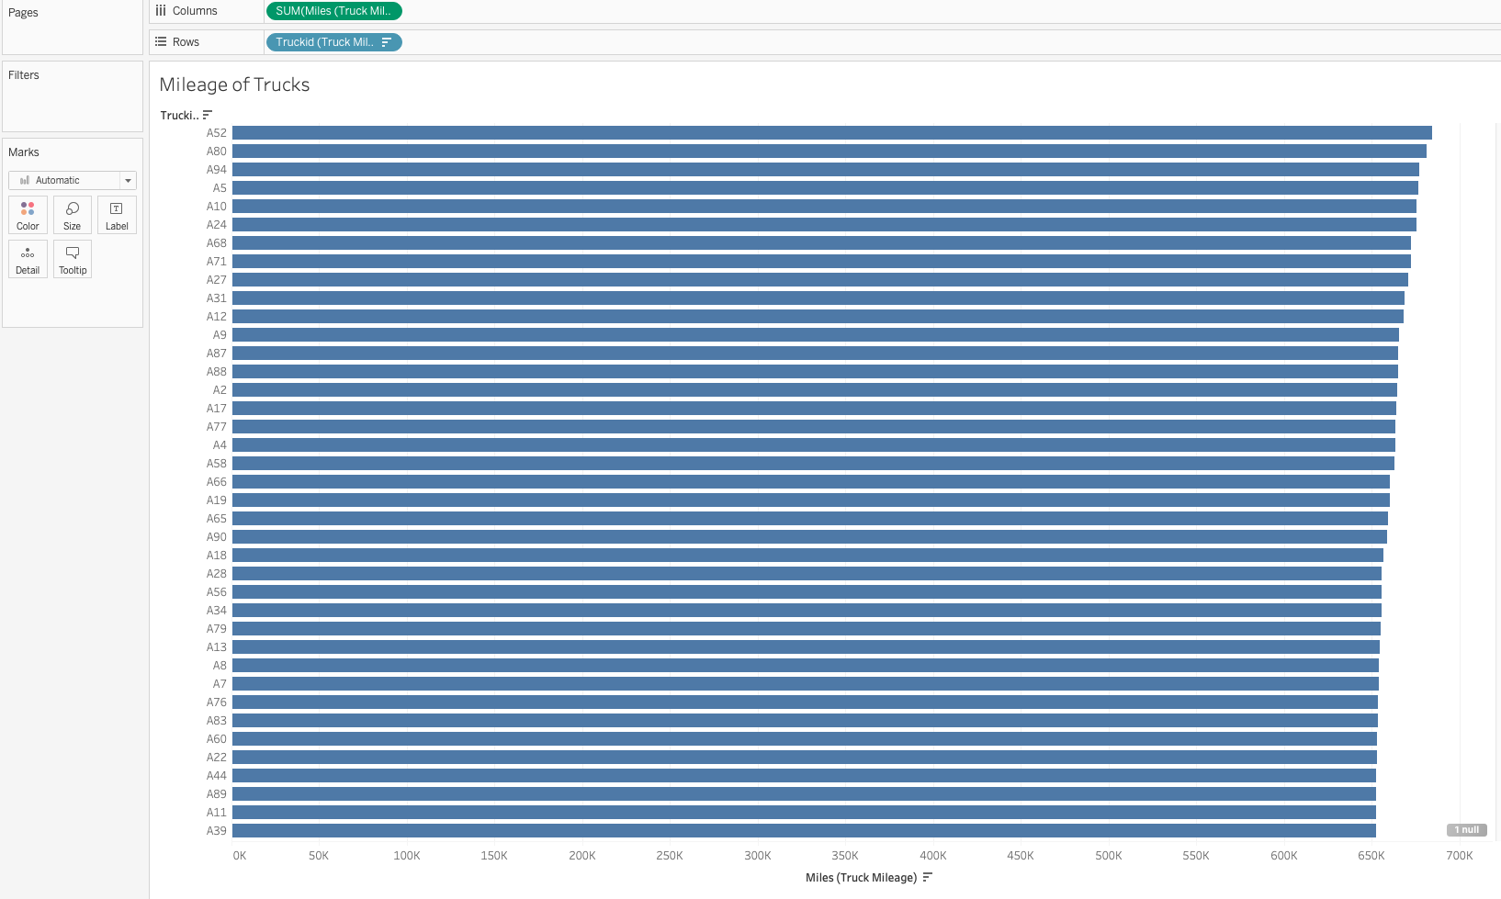

Mileage of Trucks
Chart Type: Horizontal Bar Chart (Truck IDs vs Total Miles Driven)

📌 Interpretation:
- Truck A52 has the highest total mileage, followed by A80 and A94.
- Interestingly, A52 (most miles) has relatively fewer events, which means experience or responsible usage may contribute to better performance.
- Trucks like A73 (high events) do not rank high in mileage, confirming that event frequency is not purely correlated with usage.

🔍 Insight:
High-mileage trucks aren’t always high-risk. Maintenance records or driver assignment patterns may better explain safety issues than distance alone.

Dashboard:
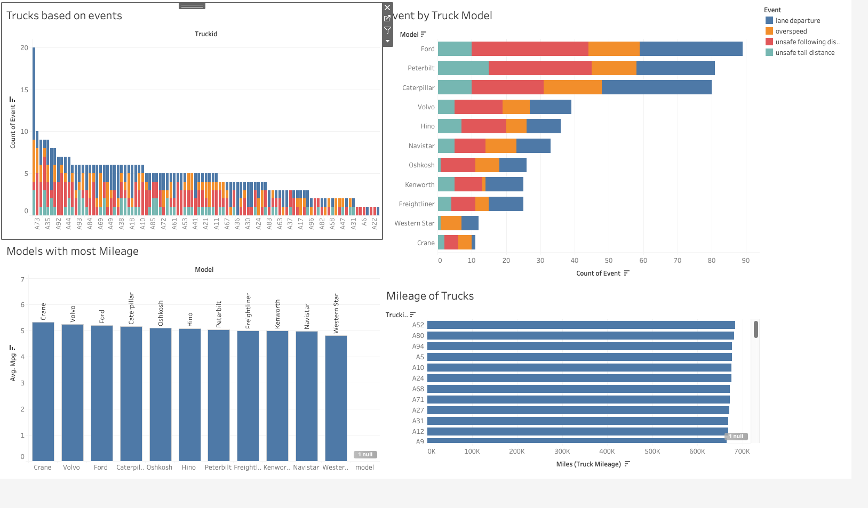

Insights:
- Truck A73 has recorded the highest number of events among all trucks — making it the riskiest based on event frequency.
- Crane model has the highest average mileage (5.32 MPG), indicating it is the most fuel-efficient model.
- Ford is the truck model with the highest number of recorded events, mostly due to unsafe following distance and lane departures.
- Interestingly, Truck A52 has the highest mileage but low number of events, showing that high usage doesn't directly relate to higher risk.

Recommendations for ANT (Advanced Network Technologies)
- Driver-Model Reassignment Strategy:
  - Avoid assigning risk-prone drivers to Ford and Peterbilt trucks unless specifically trained.
  - Prefer pairing high-mileage drivers with safer models like Crane to maintain safety and efficiency.
- Model Performance Review:
  - Audit Ford trucks for mechanical issues, tech support, or software upgrades.
  - Increase deployment of Crane or Volvo trucks for long-haul or sensitive deliveries.
- Targeted Driver Training:
  - Train drivers on mitigating lane departure and unsafe following practices.
  - Use simulation or event-based replays for drivers frequently associated with overspeed violations.
- Predictive Maintenance + Rotation Policy:
  - Place high-event trucks like A73 on maintenance hold or reduce route complexity.
  - Rotate truck usage more evenly to avoid performance degradation from overuse.

